3_ANALYSIS
3.1. Domain Model
A domain model is a visual representation of the main concepts, entities, and their relationships within a specific domain of a system. It helps in understanding the real-world objects that the system will manage and how they interact with each other.

3.2. Stakeholders
Stakeholders are the individuals, groups, or organizations that are directly or indirectly involved in a project or are affected by its outcomes. They play an important role in providing requirements, feedback, supervision, and resources for the successful completion of the project. Stakeholders may include developers, clients, end-users, and supervisors.
Stakeholders
First stakeholder is Esha Arshad , working as a developer in the Information Technology Department at Standard Girls College, Sialkot on a project for Pet Sphere . This project is customized according to the pet sphere system requirements.
Second stakeholder is Sadia Noor , working as a developer in the Information Technology Department at Standard Girls College, Sialkot on a project for Pet Sphere . This project is customized according to the pet sphere system requirements.

Third stakeholder is Mehrose Ajmal , working as a developer in the Information Technology Department at Standard Girls College, Sialkot on a project for Pet Sphere . This project is customized according to the pet sphere system requirements.
Supervisor
Under the supervision of Ma’am Zonaira, from the IT & CS Department . we are designing and developing the system for Pet Sphere Project. She provided guidance, monitoring, and academic support throughout the development process to ensure the project meets technical and educational standards.

3.3. High-Level Use Case Model
A use case model is a visual representation that shows the interaction between users also called actors and the system. It helps to identify what the users can do with the system and what the system should provide in return. Each interaction is shown as “use case” which represents a specific function or service. This model is useful for understanding system requirements and designing how the system will work from a user’s point of view. It is often represented using UML diagrams.

3.4. Low Level Use Case Models
3.4.1. Use Case Admin Registration
This is the entry point of Pet Sphere System. Only authorize user can register to the system with authenticated user name, email, address, phone number and password.
Figure 15: Customer Management
Table 14: Customer Management
Use Case ID: Use Case 01_Registration Use Case Name: Admin Registration
Actor | Admin | Web Based Application
Purpose | Manage user accounts (add, update, delete, view) | Provide user management functionality
Pre-condition | Admin must be logged in | System must be running properly
Course of Events | 1-Admin selects Manage Users. | - Displays user lists
 | 2- Add / update / delete user | - Validate data
 |  | - Saves changes
Alternative Course of events | Admin enters invalid data | System shows error message
Post condition | Users are managed successfully | User records are updated

3.4.2. Use Case Admin Login
Only authorize user can login to the system with authenticated user name and passw

Figure 15: Admin Management
Table 14: Admin Management
Use Case ID: Use Case 02_Login Use Case Name: Admin Login
Actor | Admin | Web Based Application
Purpose | Admin login to perform actions.
Pre-condition | Web-application running perfectly.
Course of Events | 1-Admin will enter the email and password. | 1-Web-application checks that the admin enter the correct email and password.
 | 2-Application checks the email and password is valid or not, if entered information is correct then the admin will be able to access the website. | 2-If admin enters incorrect information, the application will show the error message, that the admin cannot have access to website.
 | 3-Admin will login to view/perform any actions. | 3- Admin will have to re-enter the information again.
Alternative Course of events | Web-application will not Respond.
Post condition | Web-application runs successfully. | The requested service is not available.

3.4.3. Use Case Admin Panel
The admin can interact with all other modules in the system after logging in. This will provide all the functions in a single view point.

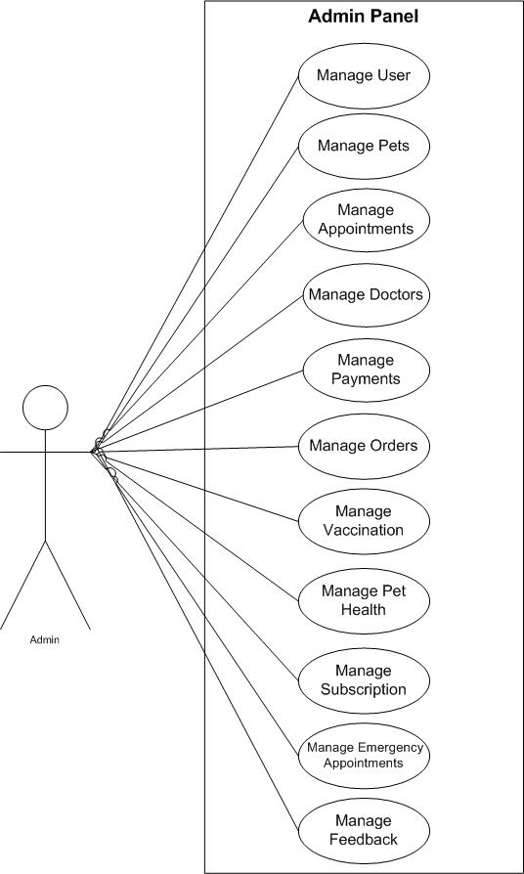

.4.4. Use Case Admin Manage User
The admin can add new salon services, update existing ones, or remove outdated services to keep the services list current and accurate.
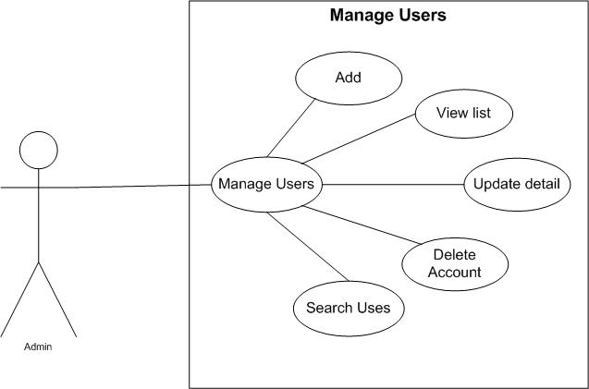
Figure 15: Manage User
Table 14: Manage User
Use Case ID: Use Case 03_Manage_Services Use Case Name: Manage_Services
Actor | Admin | Web Based Application
Purpose | Admin can add, delete, or update services.
Pre-condition | Web-application running perfectly. | System connected to database.
Course of Events | 1-Admin opens “Manage Services” page and selects add/update/delete option. | 1-Web-application validates entered data.
 | 2-Enters or edits details like Service ID, Name, Category, and Duration. | 2-Performs database update.
 | 3.Save changes. | 3-Confirms success message.
Alternative Course of events | If Service information is invalid or connection fails. | Web app shows “Unable to process request.”
Post condition | Service list updated successfully. | Database reflects new/updated/deleted records.

3.4.5. Use Case Admin Manage Pets
The admin oversees all customer bookings, ensuring appointments are properly scheduled, approved, or rescheduled when necessary.
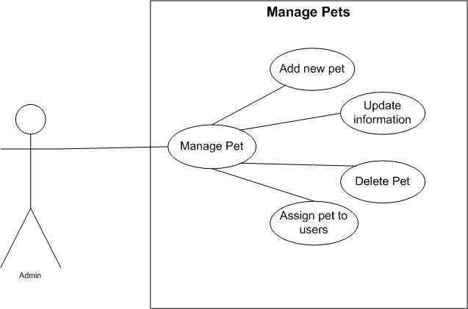
Figure 15: Manage Pet
Table 14: Manage Pet
Use Case ID: Use Case 04_Manage_Pets Use Case Name: Manage Pets
Actor | Admin | Web Based Application
Purpose | Manage all pets data | Maintain pet records
Pre-condition | Admins logged in | Database available
Course of Events | 1-Admin selects Manage pets | 1-Displays pet list
 | 2- Views / Updates pet data | 2- Saves updates
Alternative Course of events | Pet record not found | System shows error
Post condition | Pet data updated | Pet records stored

3.4.6. Use Case Admin Manage Appointments
This module allows the admin to add, update, or remove employee details and assign roles to ensure smooth operations.
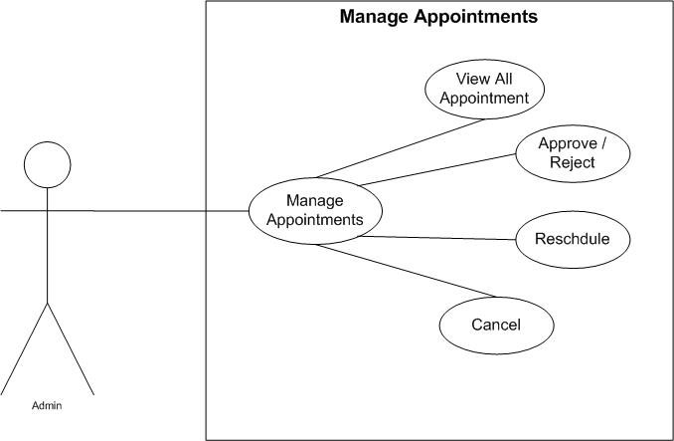
Figure 15: Manage Appointments
Table 14: Manage Appointments
Use Case ID: Use Case 05_Manage_Appointments Use Case Name: Manage Appointments
Actor | Admin | Web Based Application
Purpose | View and manage appointments | Handle appointment scheduling
Pre-condition | Admin logged in | System active
Course of Events | 1-Admin selects manage appointments | 1-Display appointments
 | 2-Approve / Cancels appointments | 2-Updates status.
Alternative Course of events | Appointment not available | Error message displayed
Post condition | Appointment managed | Appointment status updated

3.4.7. Use Case Admin Manage Doctor
The admin can view and track all past customer appointments for performance monitoring and reporting purposes.
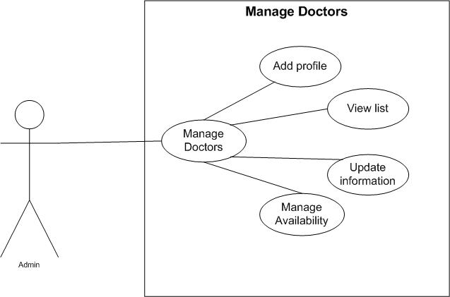
Figure 15: Manage Doctor
Table 14: Manage Doctor
Use Case ID: Use Case 06_Manage_Doctor Use Case Name: Manage Doctor
Actor | Admin | Web Based Application
Purpose | Add, update, remove doctors | Store doctor information
Pre-condition | Admin logged in | System available
Course of Events | 1-Admin selects Manage Doctors | 1-Validates data
 | 2- Enters doctor details | 2- Saves doctor record
Alternative Course of events | Duplicate doctor record | Error message shown
Post condition | Doctor data updated | Doctor list updated

3.4.8. Use Case Admin Payment
This module helps the admin view, generate, and analyze payment transactions and financial summaries making.
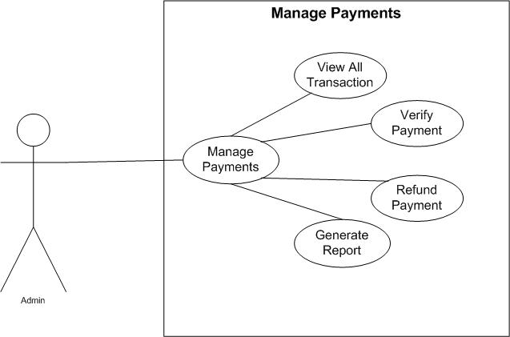
Figure 15: Manage Payments
Table 14: Manage Payments
Use Case ID: Use Case 06_Manage_Payments Use Case Name: Manage Payments
Actor | Admin | Web Based Application
Purpose | Monitor and manage payments | Process payment records
Pre-condition | Admin logged in | Payment system active
Course of Events | 1-Admin views payments | 1-Displays payment data
 | 2-Confirms transaction | 2-Updates payment status
Alternative Course of events | Payment data missing | Error shows
Post condition | Payment verified | Payment records updated

3.4.8. Use Case Admin Manage Orders
This module helps the admin view, generate, and analyze payment transactions and financial summaries making.
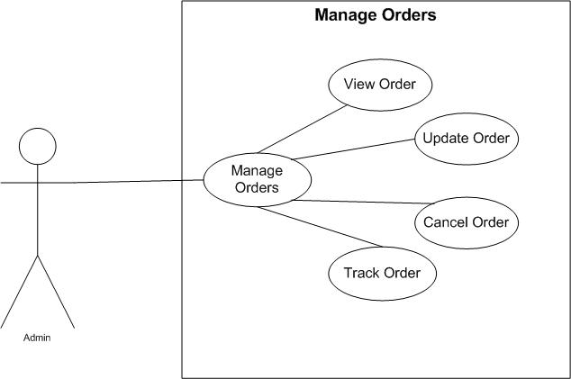
Figure 15: Manage Orders
Table 14: Manage Orders
Use Case ID: Use Case 06_Manage_Orders Use Case Name: Manage Orders
Actor | Admin | Web Based Application
Purpose | Manage customer orders | Handle order processing
Pre-condition | Admin logged in | Inventory available
Course of Events | 1-Admin views orders | 1-Displays order list
 | 2-Updates order status | 2-Saves status
Alternative Course of events | Order not found | Error message
Post condition | Order managed | Order updated

3.4.8. Use Case Admin Manage Vaccination
This module helps the admin view, generate, and analyze payment transactions and financial summaries making.
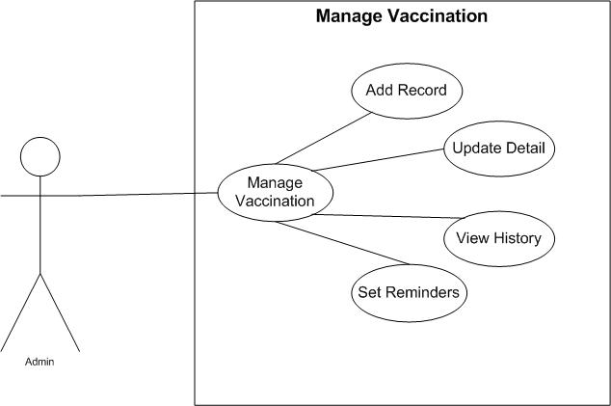
Figure 15: Manage Vaccination
Table 14: Manage Vaccination
Use Case ID: Use Case 06_Manage_Vaccination Use Case Name: Manage Vaccination
Actor | Admin | Web Based Application
Purpose | Maintain vaccination records | Store vaccination data
Pre-condition | Admin logged n | Pet record exists
Course of Events | 1- Admin updates vaccination info | 1-. Validates data
 |  | 2-Saves record
Alternative Course of events | Invalid vaccination data | Error shown
Post condition | Vaccination updated | Vaccination record saved
3.4.8. Use Case Admin Manage Pet Health
This module helps the admin view, generate, and analyze payment transactions and financial summaries making.
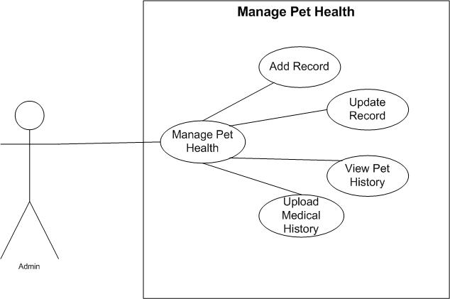
Figure 15: Manage Pet Health
Table 14: Manage Pet Health
Use Case ID: Use Case 06_Manage_Pet_Health Use Case Name: Manage Pet Health
Actor | Admin | Web Based Application
Purpose | Monitor pet health records | Maintain health history
Pre-condition | Admin logged in | Pet data available
Course of Events | 1- Admin views / updates health data | 1- Displays health information
 |  | 2-Save changes
Alternative Course of events | Health data missing | Error shown
Post condition | Health data updated | Health record stored

3.4.8. Use Case Admin Manage Subscription
This module helps the admin view, generate, and analyze payment transactions and financial summaries making.
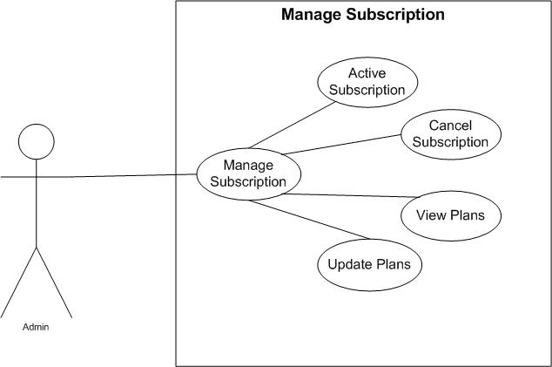
Figure 15: Manage Subscription
Table 14: Manage Subscription
Use Case ID: Use Case 06_Manage_Subscription Use Case Name: Manage Subscription
Actor | Admin | Web Based Application
Purpose | Manage user subscription | Handle subscription plans
Pre-condition | Admin logged in | Subscription module active
Course of Events | 1- Admin updates subscription plans | 1- Displays plans
 |  | 2- Saves updates
Alternative Course of events | Subscription error | Error displayed
Post condition | Subscription managed | Subscription updated

.8. Use Case Admin Manage Emergency Alert
This module helps the admin view, generate, and analyze payment transactions and financial summaries making.
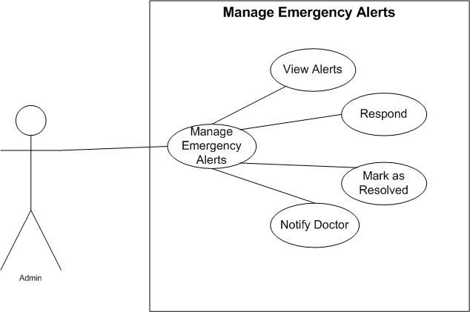
Figure 15: Manage Emergency Alerts
Table 14: Manage Emergency Alerts
Use Case ID: Use Case 06_Manage_Emergency_Alerts Use Case Name: Manage Emergency Alerts
Actor | Admin | Web Based Application
Purpose | Handle emergency requests | Notify doctors and users
Pre-condition | Admin logged in | Emergency system active
Course of Events | 1- Admin views emergency alerts | 1- Sends notifications
 |  | 2-Updates alert status
Alternative Course of events | No doctor available | Alert remains pending
Post condition | Emergency handled | Alert processed
3.4.8. Use Case Admin Manage Feedback
This module helps the admin view, generate, and analyze payment transactions and financial summaries making.
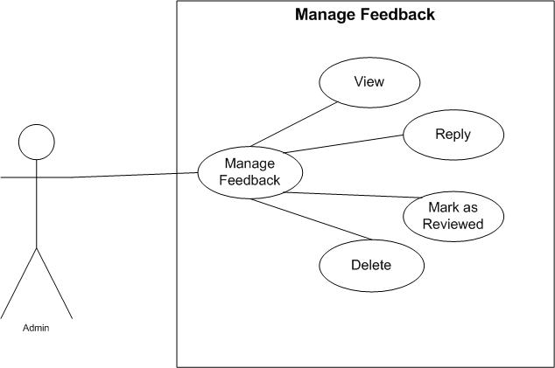
Figure 15: Manage Feedback
Table 14: Manage Feedback
Use Case ID: Use Case 06_Manage_Feedback Use Case Name: Manage Feedback
Actor | Admin | Web Based Application
Purpose | View and manage feedback | Store feedback data
Pre-condition | Admin logged in | Feedback module active
Course of Events | 1- Admin views feedback | 1-Display Feedback list
Alternative Course of events | Feedback not available | Message Shown
Post condition | Feedback reviewed | Feedback stored successfully

Use Case Customer Registration & Login

Figure 19: Customer Registration & Login

Table 18: Customer Registration & Login

Use Case ID: Use Case 01_Customer_Registration_and_Login Use Case Name: Customer_Registration and_Login
Actor | Customer | Web Based Application
Purpose | Customer can register to perform actions.
Pre-condition | Web-application running perfectly.
Course of Events | 1-Customer will Request for registration. The System will load the register form and Display. Customer will provide the register form information. | 1-Web-application checks that the customer enters the correct username, email, and password.
 | 2-The System will verify and if customer provide correct information. | 2-If customer enters incorrect information, he/she will not have access to the website.
 |  | 3-Customer will have to re- enter the information again.
Alternative Course of events | Web-application will not Respond.
Post condition | Web-application runs successfully. | The requested service is not available.

Use Case Customer Panel
The customer can interact with all other modules in the system after logging in. This will provide all the function information in a single view point.

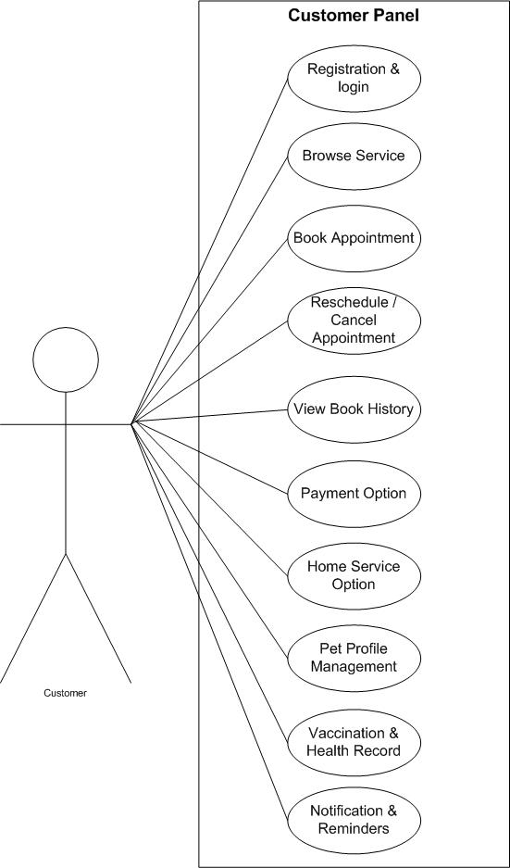

Use Case Customer Browse List of Services
Customers can view all available salon/spa services along with their name, category, duration, and price.

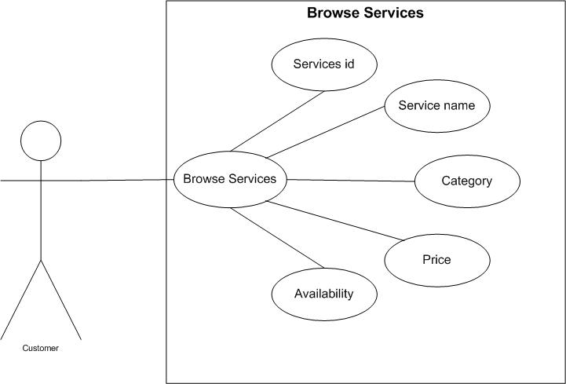

Figure 21: Browse List of Services
Table 19: Browse List of Services

Use Case ID: Use Case 02_Browse_List_of_Services Use Case Name: Browse List of Services
Actor | Customer | Web Based Application
Purpose | View available pet services | Display services
Pre-condition | Customer logged in | Services available
Course of Events | 1-Customer selects browse services | 1-Display service list
Alternative Course of events | No service available | Shows message
Post condition | Services viewed | Service shown

Use Case Customer Book Appointment
Customers can view all available salon/spa services along with their name, category, duration, and price.

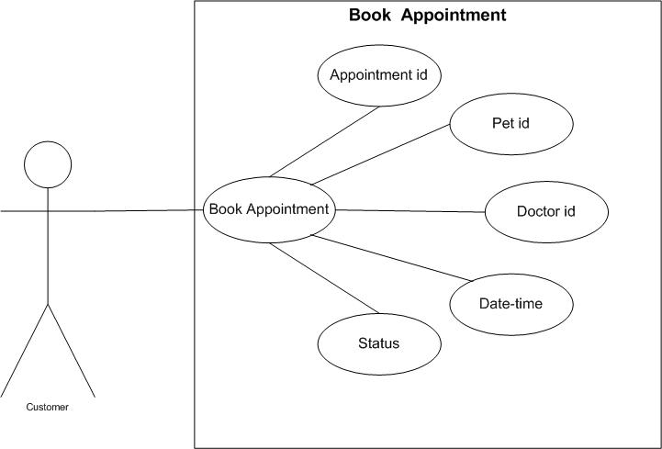

Figure 21: Book Appointment
Table 19: Book Appointment

Use Case ID: Use Case 02_Browse_Appointment
Use Case Name: Book Appointment
Actor | Customer | Web Based Application
Purpose | Book appointment with doctor | Schedule appointment
Pre-condition | Customer logged in, pet registered | Appointment slots available
Course of Events | 1-Selets doctor / date / time | 1-Confirms appointment
Alternative Course of events | Slot unavailable | Shows error
Post condition | Appointment booked | Appointment stored

Use Case Customer Reschedule / Cancel Appointment
Customers can view all available salon/spa services along with their name, category, duration, and price.

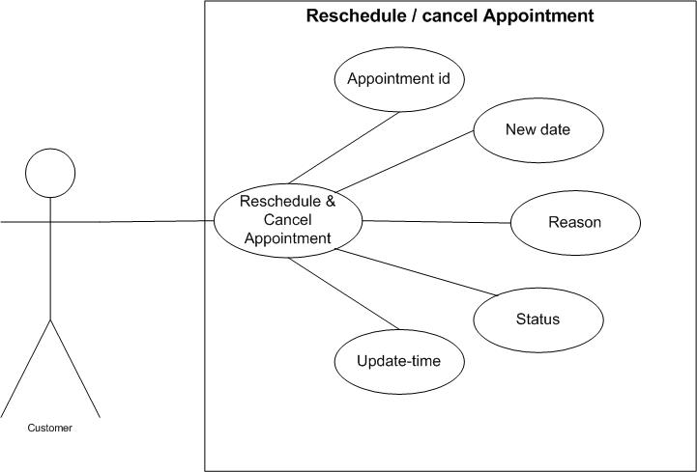

Figure 21: Reschedule / Cancel Appointment
Table 19: Reschedule / Cancel Appointment

Use Case ID: Use Case 02_Reschedule_Appointment
Use Case Name: Reschedule/Cancel Appointment
Actor | Customer | Web Based Application
Purpose | Modify or cancel appointment | Updated appointment
Pre-condition | Existing appointment | System active
Course of Events | 1- Selects appointments, Reschedule / cancel | 1-Updated appointment
Alternative Course of events | Appointment not found | Shows error
Post condition | Appointment updated | Record updated

Use Case Customer View Booking History
Customers can view all available salon/spa services along with their name, category, duration, and price.

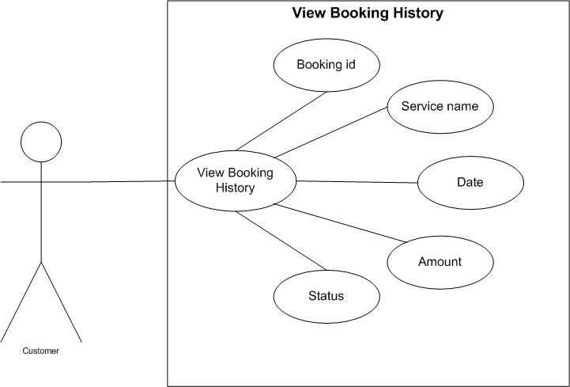

Figure 21: View Booking History
Table 19: View Booking History

Use Case ID: Use Case 02_View_Booking_History Use Case Name: View Booking History
Actor | Customer | Web Based Application
Purpose | View past appointments | Display history
Pre-condition | Customer logged in | Booking data available
Course of Events | 1-Selects booking history | 1-Display history
Alternative Course of events | No history | Shows message
Post condition | History viewed | History shown

Use Case Customer Payment Option
Customers can view all available salon/spa services along with their name, category, duration, and price.

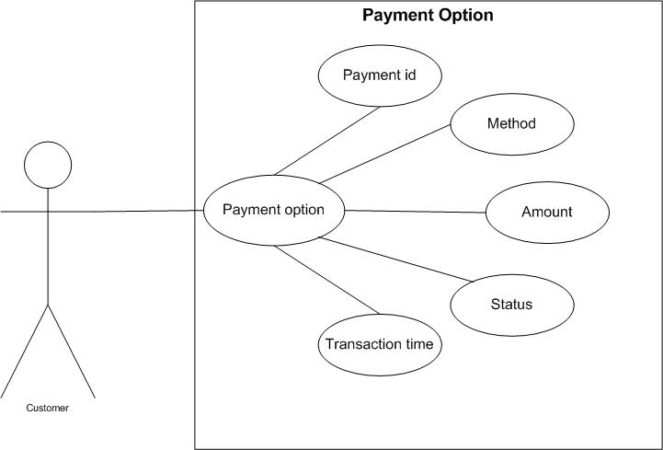

Figure 21: Payment Option
Table 19: Payment Option

Use Case ID: Use Case 02_Browse_List_of_Services Use Case Name: Payment Option
Actor | Customer | Web Based Application
Purpose | Make payment for services | Process payment
Pre-condition | Appointment/ order exists | Payment gateway active
Course of Events | 1-Selects payment method | 1-Processes payment
Alternative Course of events | Payment failed | Shows failure message
Post condition | Payment completed | Payment recorded

Use Case Customer Home Service Option
Customers can view all available salon/spa services along with their name, category, duration, and price.

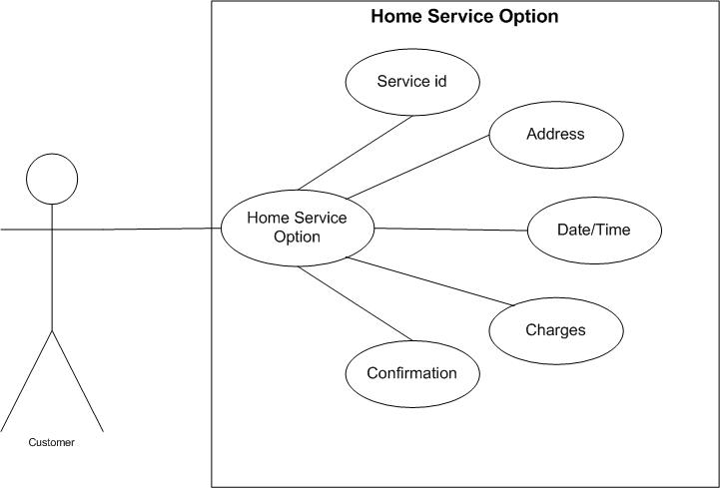

Figure 21: Home Service Option
Table 19: Home Service Option

Use Case ID: Use Case 02_Browse_List_of_Services Use Case Name: Home Service Option
Actor | Customer | Web Based Application
Purpose | Request home service | Schedule home visit
Pre-condition | Customer logged in | Service available
Course of Events | - Selects home Service | 1-Confirms request
Alternative Course of events | Service unavailable | Shows message
Post condition | Home service requested | Request saved

Use Case Customer Pet Profile Management
Customers can view all available salon/spa services along with their name, category, duration, and price.

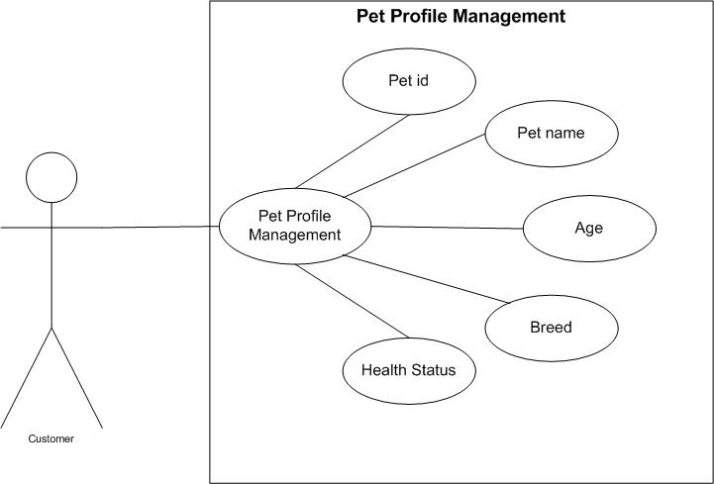

Figure 21: Pet Profile Management
Table 19: Pet Profile Management

Use Case ID: Use Case 02_Browse_List_of_Services Use Case Name: Pet Profile Management
Actor | Customer | Web Based Application
Purpose | Manage pet profile | Store pet data
Pre-condition | Customer logged in | Database available
Course of Events | 1-Adds / Updates pet info | 1-Saves pet profile
Alternative Course of events | Invalid data | Shows error
Post condition | Pet profile updated | Data saved

Use Case Customer Vaccination and Health Record
Customers can view all available salon/spa services along with their name, category, duration, and price.

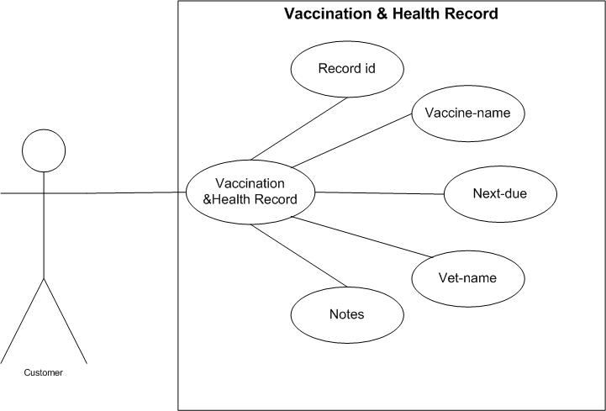

Figure 21: Vaccination & Health Record
Table 19: Vaccination & Health Record

Use Case ID: Use Case 02_Browse_List_of_Services Use Case Name: Vaccination & Health Record
Actor | Customer | Web Based Application
Purpose | View pet health records
Pre-condition | Pet registered
Course of Events | 1-Views vaccination & health | 1-
 | 2- | 2-.
Alternative Course of events | Records not found
Post condition

Use Case Customer Browse List of Services
Customers can view all available salon/spa services along with their name, category, duration, and price.

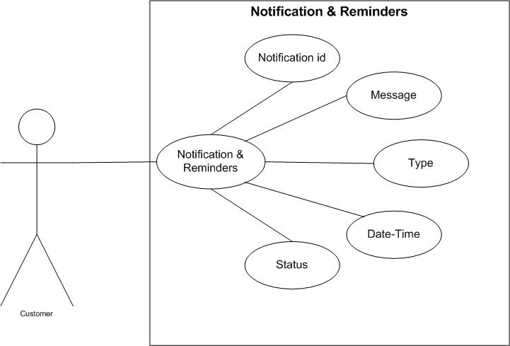

Figure 21: Browse List of Services
Table 19: Browse List of Services

Use Case ID: Use Case 02_Browse_List_of_Services Use Case Name: Browse_List_of_Services
Actor | Customer | Web Based Application
Purpose
Pre-condition
Course of Events | 1- | 1-
 | 2- | 2-
Alternative Course of events
Post condition

Use Case Doctor Registration & Login

User Name
<<include>>
Accept
Login
Failed
<<include>>
Reject
Customer
Password
Figure 19: Customer Registration & Login

Table 18: Customer Registration & Login

Use Case ID: Use Case 01_Customer_Registration_and_Login Use Case Name: Customer_Registration_and_Login
Actor | Customer | Web Based Application
Purpose
Pre-condition
Course of Events | 1- | 1-
 | 2- | 2-
 |  | 3-
Alternative Course of events
Post condition

Use Case Doctor Panel
The customer can interact with all other modules in the system after logging in. This will provide all the function information in a single view point.

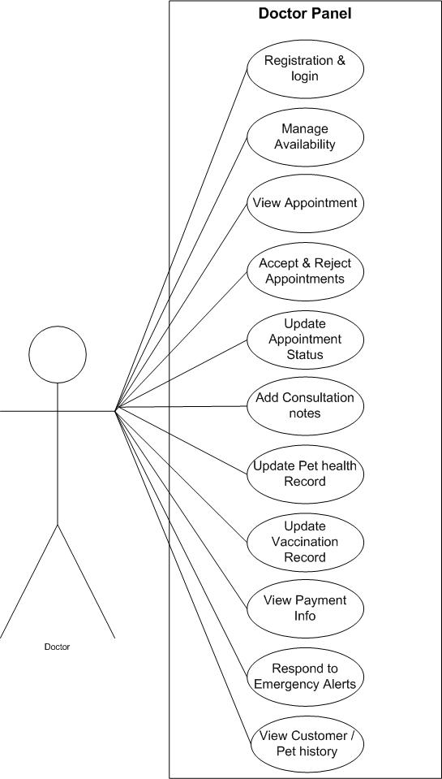

Use Case Customer Browse List of Services
Customers can view all available salon/spa services along with their name, category, duration, and price.

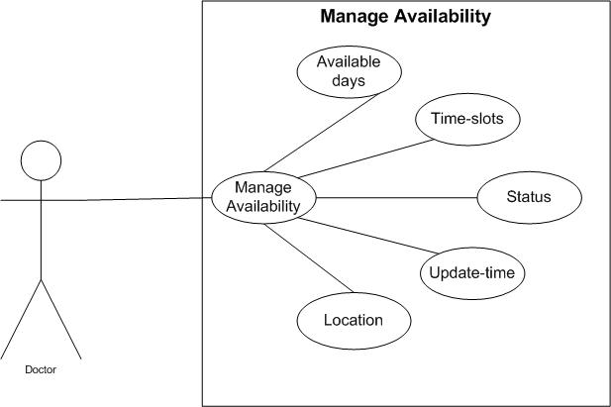

Figure 21: Browse List of Services
Table 19: Browse List of Services

Use Case ID: Use Case 02_Browse_List_of_Services Use Case Name: Browse_List_of_Services
Actor | Customer | Web Based Application
Purpose
Pre-condition
Course of Events | 1- | 1-
 | 2- | 2-
Alternative Course of events
Post condition

Use Case Customer Browse List of Services
Customers can view all available salon/spa services along with their name, category, duration, and price.

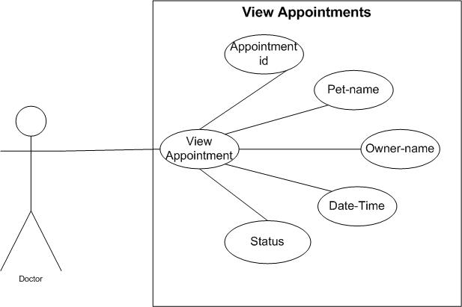

Figure 21: Browse List of Services
Table 19: Browse List of Services

Use Case ID: Use Case 02_Browse_List_of_Services Use Case Name: Browse_List_of_Services
Actor | Customer | Web Based Application
Purpose
Pre-condition
Course of Events | 1- | 1-
 | 2- | 2-
Alternative Course of events
Post condition

Use Case Customer Browse List of Services
Customers can view all available salon/spa services along with their name, category, duration, and price.

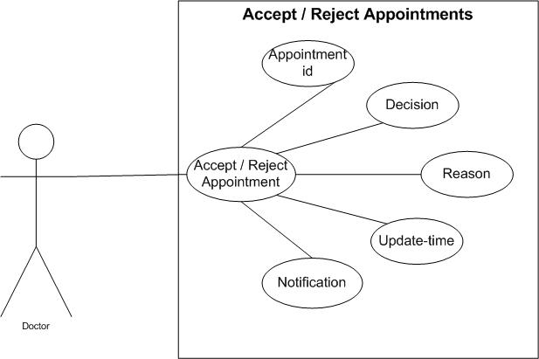

Figure 21: Browse List of Services
Table 19: Browse List of Services

Use Case ID: Use Case 02_Browse_List_of_Services Use Case Name: Browse_List_of_Services
Actor | Customer | Web Based Application
Purpose
Pre-condition
Course of Events | 1- | 1-
 | 2- | 2-
Alternative Course of events
Post condition

Use Case Customer Browse List of Services
Customers can view all available salon/spa services along with their name, category, duration, and price.

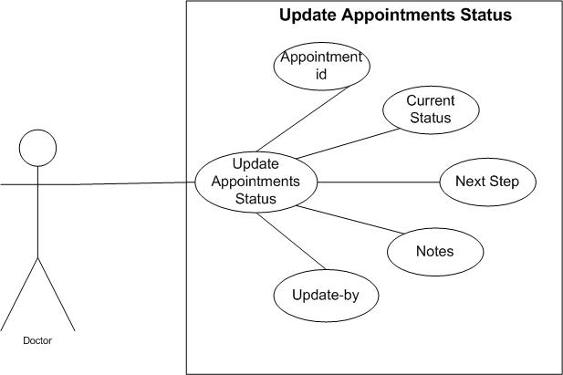

Figure 21: Browse List of Services
Table 19: Browse List of Services

Use Case ID: Use Case 02_Browse_List_of_Services Use Case Name: Browse_List_of_Services
Actor | Customer | Web Based Application
Purpose
Pre-condition
Course of Events | 1- | 1-
 | 2- | 2-
Alternative Course of events
Post condition | .

Use Case Customer Browse List of Services
Customers can view all available salon/spa services along with their name, category, duration, and price.

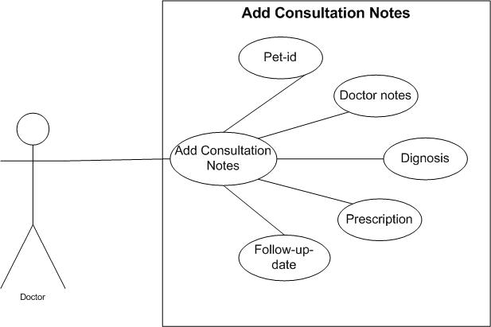

Figure 21: Browse List of Services
Table 19: Browse List of Services

Use Case ID: Use Case 02_Browse_List_of_Services Use Case Name: Browse_List_of_Services
Actor | Customer | Web Based Application
Purpose
Pre-condition
Course of Events | 1- | 1-
 | 2- | 2-
Alternative Course of events
Post condition

Use Case Customer Browse List of Services
Customers can view all available salon/spa services along with their name, category, duration, and price.

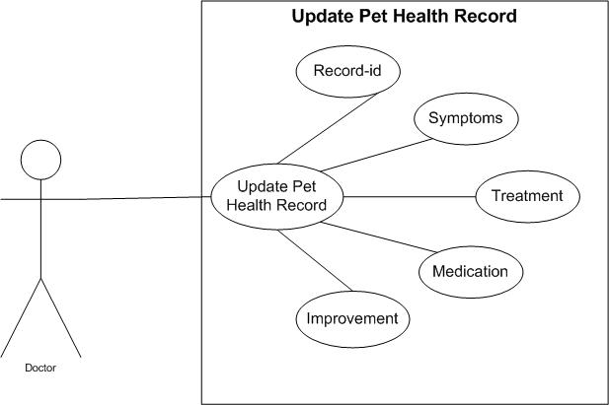

Figure 21: Browse List of Services
Table 19: Browse List of Services

Use Case ID: Use Case 02_Browse_List_of_Services Use Case Name: Browse_List_of_Services
Actor | Customer | Web Based Application
Purpose
Pre-condition
Course of Events | 1- | 1-
 | 2- | 2-
Alternative Course of events
Post condition

Use Case Customer Browse List of Services
Customers can view all available salon/spa services along with their name, category, duration, and price.

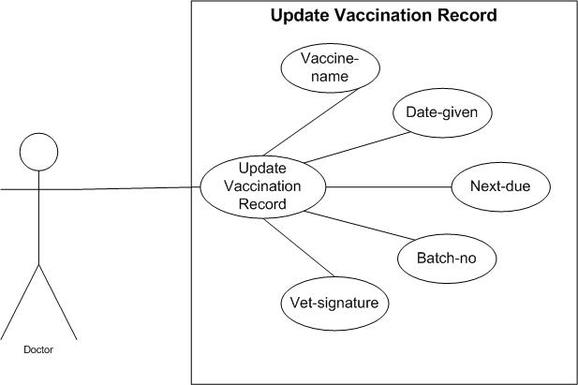

Figure 21: Browse List of Services
Table 19: Browse List of Services

Use Case ID: Use Case 02_Browse_List_of_Services Use Case Name: Browse_List_of_Services
Actor | Customer | Web Based Application
Purpose
Pre-condition | .
Course of Events | 1- | 1-
 | 2- | 2-
Alternative Course of events
Post condition

Use Case Customer Browse List of Services
Customers can view all available salon/spa services along with their name, category, duration, and price.

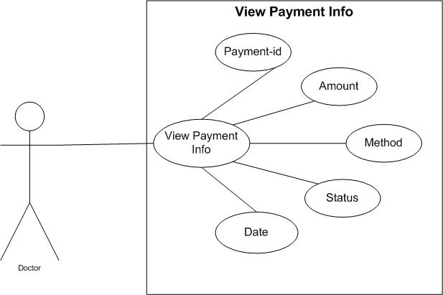

Figure 21: Browse List of Services
Table 19: Browse List of Services

Use Case ID: Use Case 02_Browse_List_of_Services Use Case Name: Browse_List_of_Services
Actor | Customer | Web Based Application
Purpose
Pre-condition | .
Course of Events | 1- | 1-
 | 2- | 2-
Alternative Course of events
Post condition

Use Case Customer Browse List of Services
Customers can view all available salon/spa services along with their name, category, duration, and price.

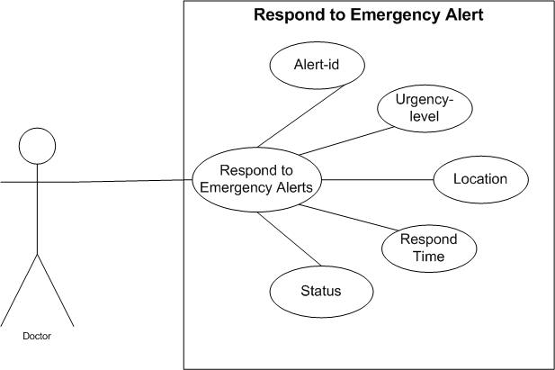

Figure 21: Browse List of Services
Table 19: Browse List of Services

Use Case ID: Use Case 02_Browse_List_of_Services Use Case Name: Browse_List_of_Services
Actor | Customer | Web Based Application
Purpose
Pre-condition
Course of Events | 1- | 1-
 | 2- | 2-
Alternative Course of events
Post condition

Use Case Customer Browse List of Services
Customers can view all available salon/spa services along with their name, category, duration, and price.

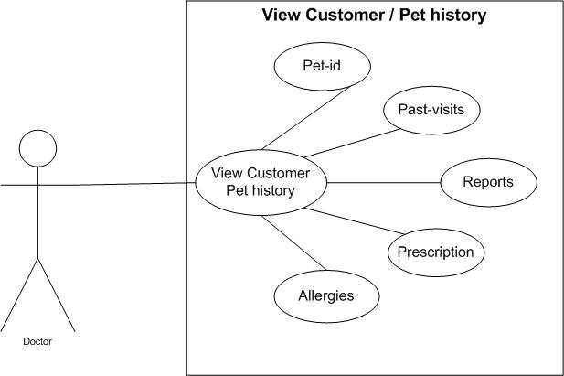

Figure 21: Browse List of Services
Table 19: Browse List of Services

Use Case ID: Use Case 02_Browse_List_of_Services Use Case Name: Browse_List_of_Services
Actor | Customer | Web Based Application
Purpose
Pre-condition
Course of Events | 1- | 1-
 | 2- | 2-
Alternative Course of events
Post condition

Use Case Customer Browse List of Services
Customers can view all available salon/spa services along with their name, category, duration, and price.



Figure 21: Browse List of Services
Table 19: Browse List of Services

Use Case ID: Use Case 02_Browse_List_of_Services Use Case Name: Browse_List_of_Services
Actor | Customer | Web Based Application
Purpose
Pre-condition
Course of Events | 1- | 1-
 | 2- | 2-
Alternative Course of events
Post condition

System Sequence Diagram
A sequence diagram is a type of UML diagram that shows how objects interact with each other in a specific order over time. It focuses on the sequence of messages exchanged between different system components to complete a process or function. The diagram uses lifelines and arrows to represent objects and their communication. It helps visualize the flow of control and data within a system.

Sequence Diagrams for Admin Panel

Registration & Login

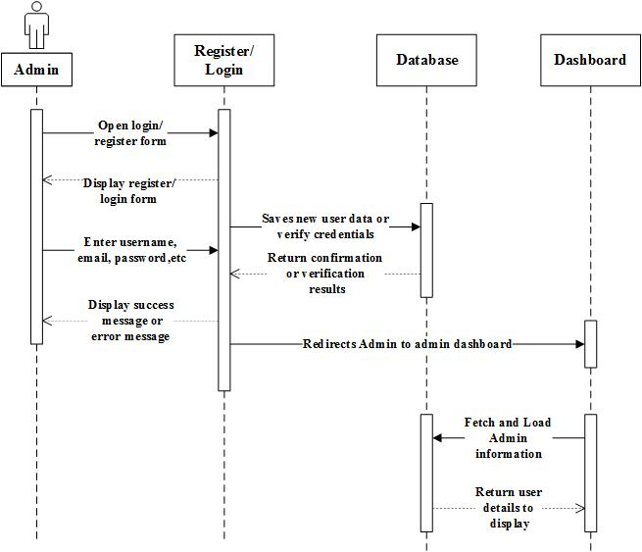

Figure 31: Sequence Diagram for Registration & Login

- Manage User

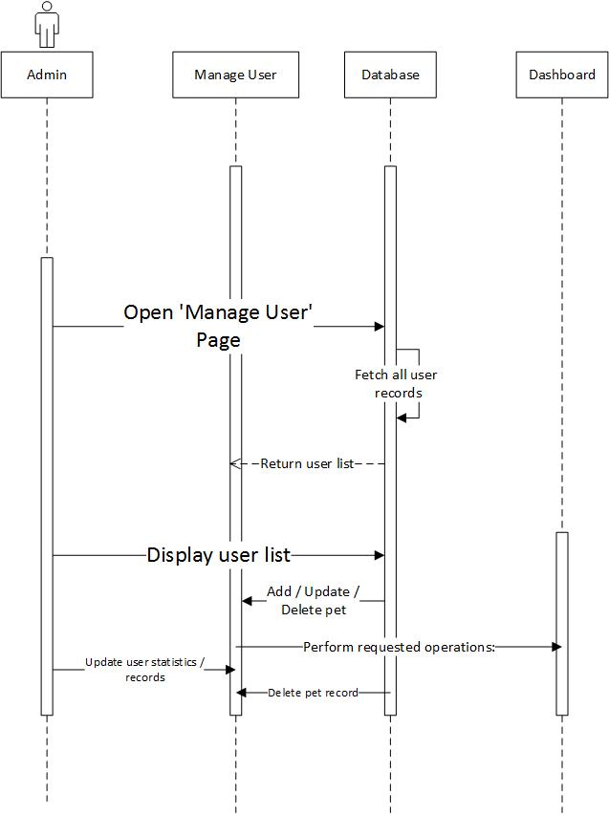
Figure 32: Sequence Diagram for Manage User
- Manage Pets
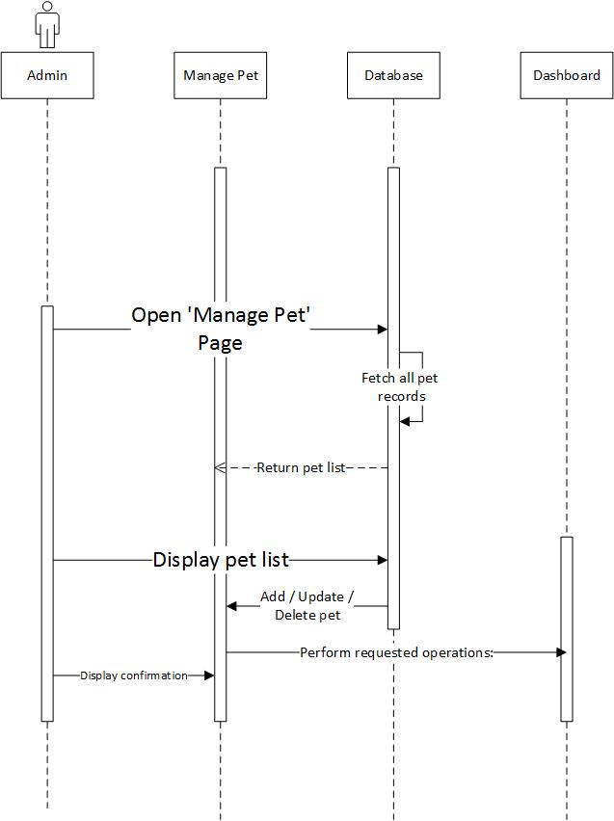
Figure 32: Sequence Diagram for Manage Pets
- Manage Appointments
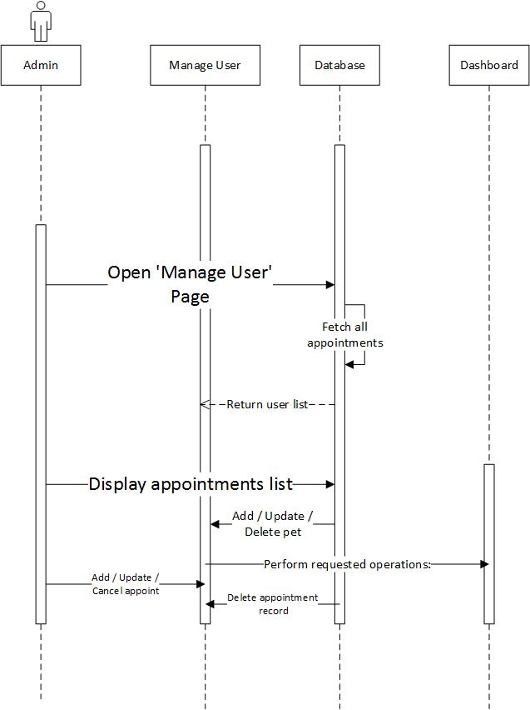
Figure 32: Sequence Diagram for Manage Appointment

- Manage Doctors
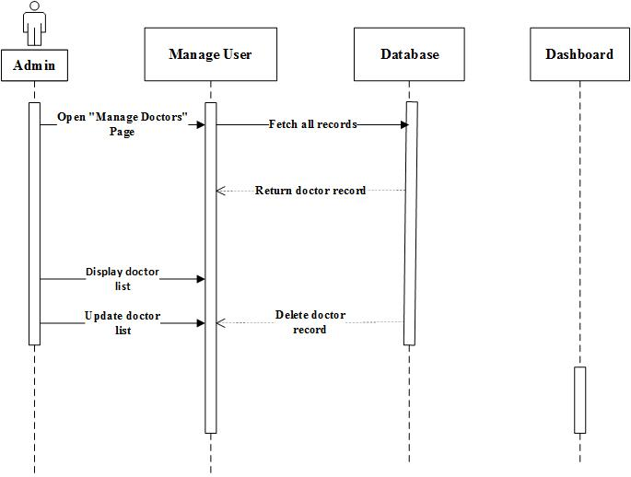
Figure 32: Sequence Diagram for Manage Doctors
- Manage Payments
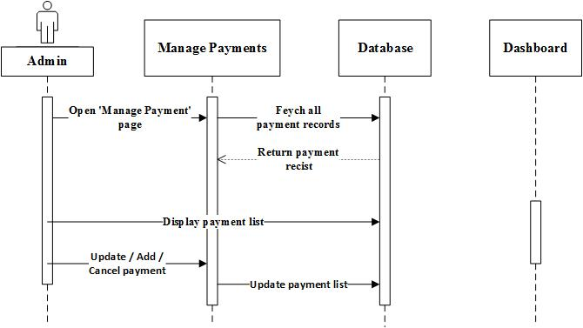
Figure 32: Sequence Diagram for Manage Payments
- Manage Order
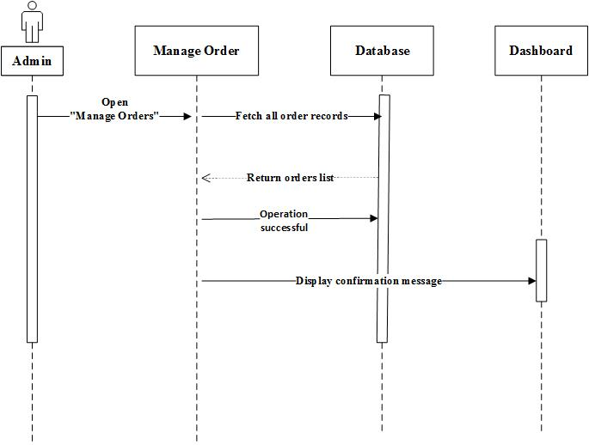
Figure 32: Sequence Diagram for Manage Order
- Manage Vaccination
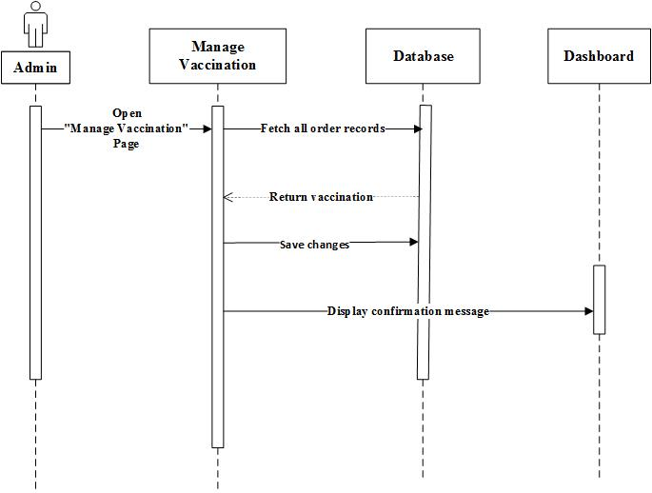
Figure 32: Sequence Diagram for Manage Vaccination
- Manage Pet Health

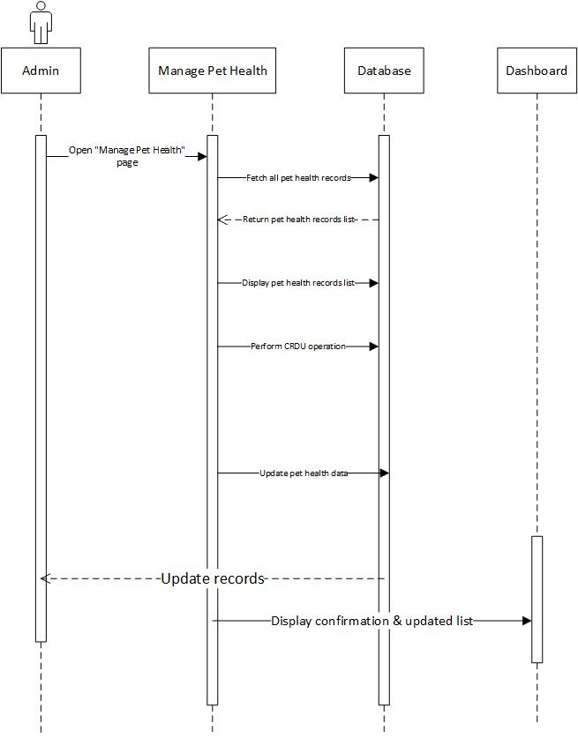
Figure 32: Sequence Diagram for Manage Pet Health
- Manage Subscription
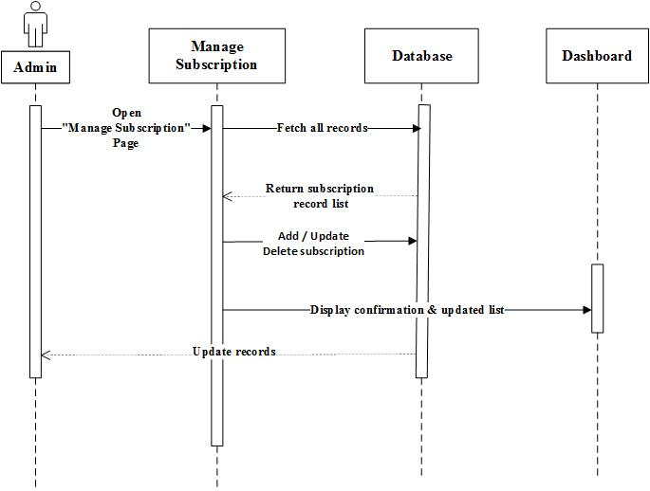
Figure 32: Sequence Diagram for Manage Subscription

- Manage Emergency Alert

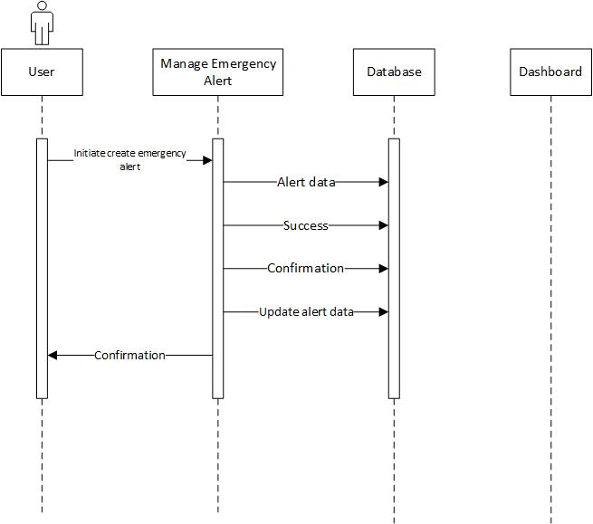
Figure 32: Sequence Diagram for Manage Emergency Alerts
- Manage Feedback

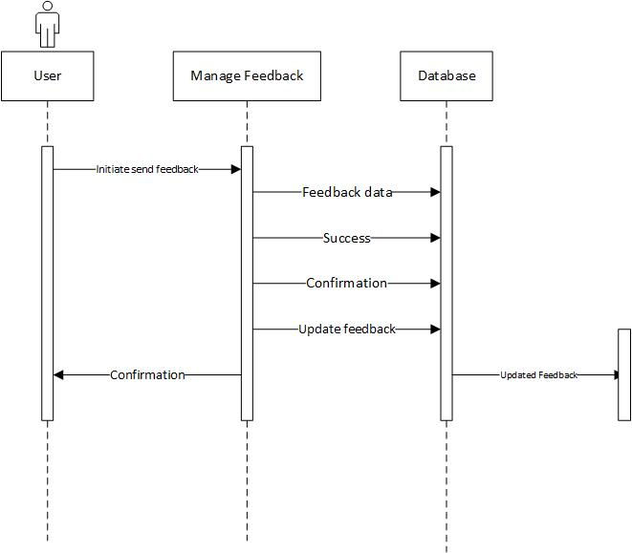

Figure 32: Sequence Diagram for Manage Feedback

Sequence Diagrams for Customer Panel

Customer Register/Login



Figure 43: Sequence Diagram for Customer Register/Login

- Browse Service
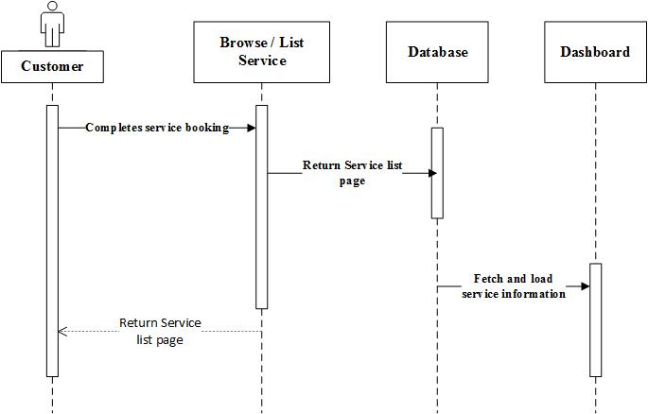
Figure 44: Sequence Diagram for Browse Service
- Book Appointment
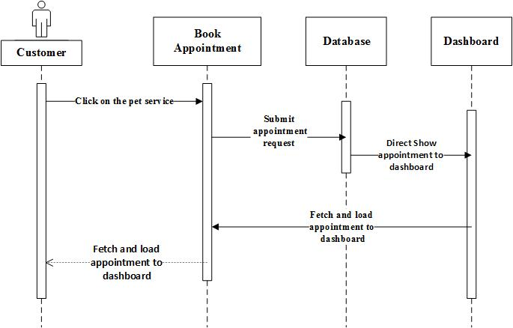
Figure 47: Sequence Diagram for Book Appointment
4-Reschedule / Cancel Appointment
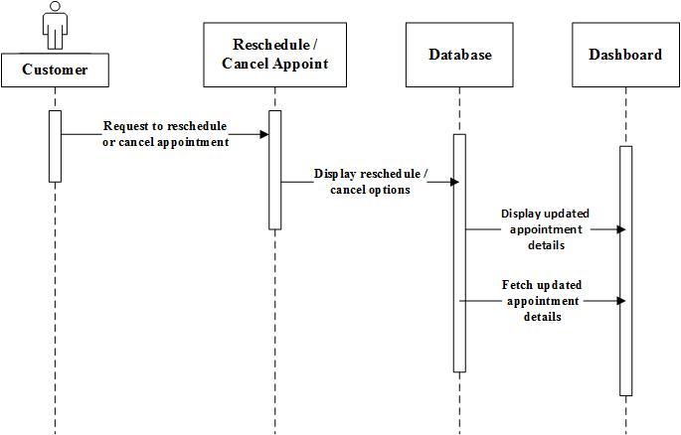
Figure 47: Sequence Diagram for Reschedule / Cancel Appointment

- View Book history
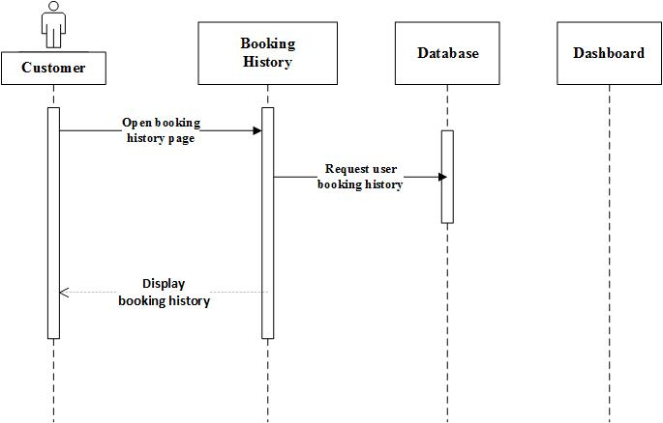

Figure 47: Sequence Diagram for Booking history
- Payment Option
Figure 47: Sequence Diagram for Payment Option
- Home Service Option
Figure 47: Sequence Diagram for Home Service Option
- Pet Profile Management
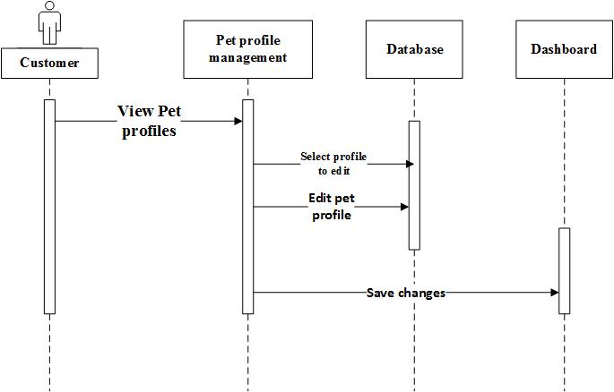
Figure 47: Sequence Diagram for Pet profile Management
- Vaccination & Health Record
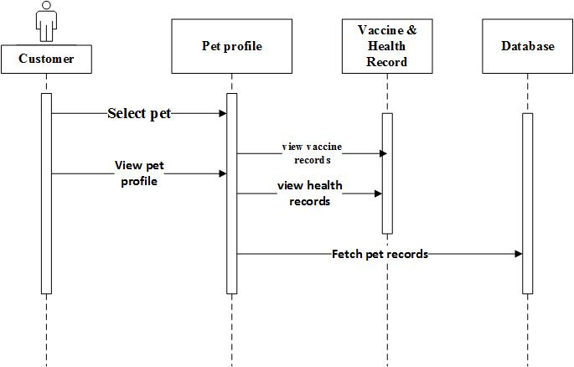
Figure 47: Sequence Diagram for Vaccination & Health Record

- Notification & Reminders
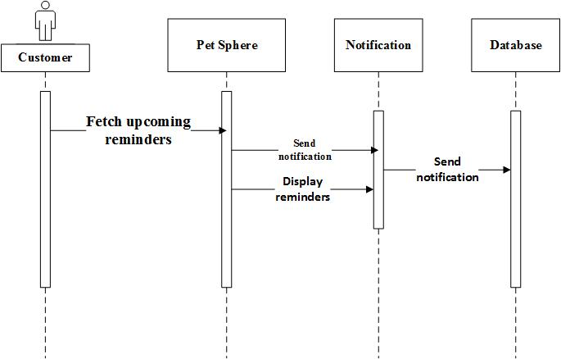

Figure 47: Sequence Diagram for Notifications & Reminders

Sequence Diagrams for Doctor Panel

Doctor Register/Login

Figure 47: Sequence Diagram for Register & Login

- Manage Availability
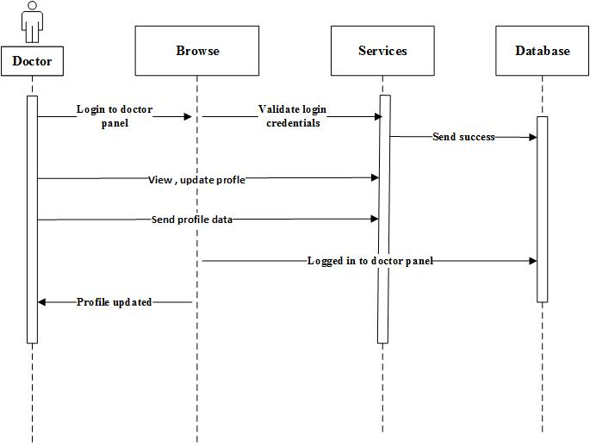
Figure 47: Sequence Diagram for Manage Availability

- View Appointment
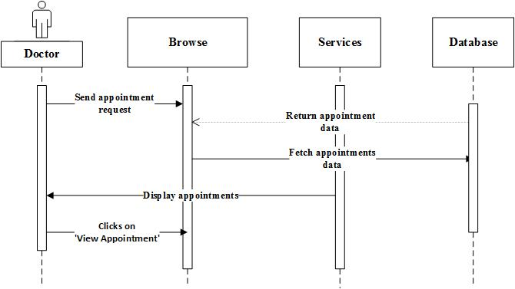
Figure 47: Sequence Diagram for View Appointment

- Accept & Reject Appointment
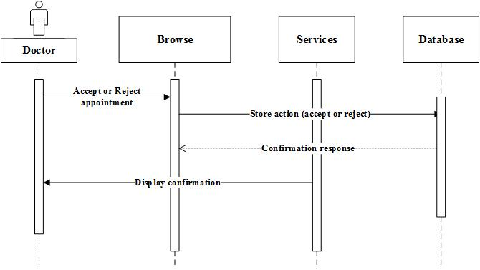
Figure 47: Sequence Diagram for Accept & Reject Appointment

- Update Appointment Status

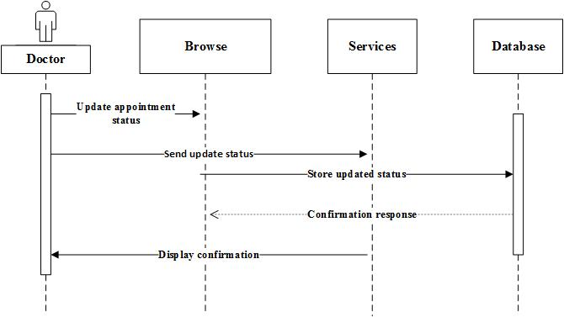
Figure 47: Sequence Diagram for Update Appointment Status

- Add Consultation Notes
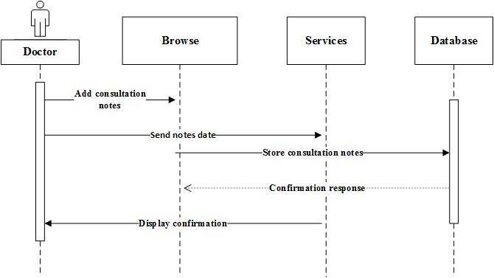
Figure 47: Sequence Diagram for Add consultation Notes
- Update Pet health Record
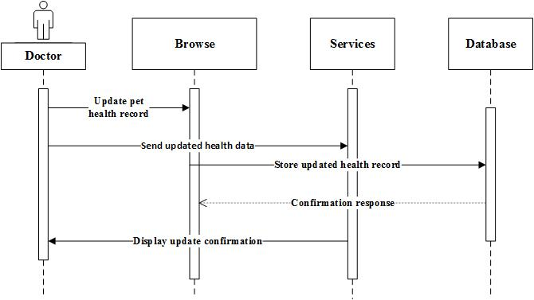
Figure 47: Sequence Diagram for Update Pet health Record

- Update Vaccination Record
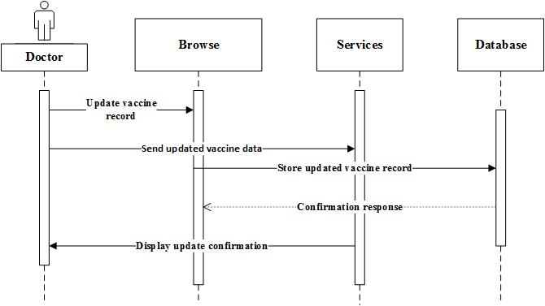
Figure 47: Sequence Diagram for Update Vaccination Record
- View payment info
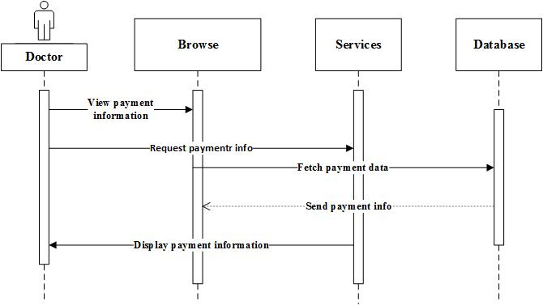
Figure 47: Sequence Diagram for Update Vaccination Record
- Respond to Emergency Alerts

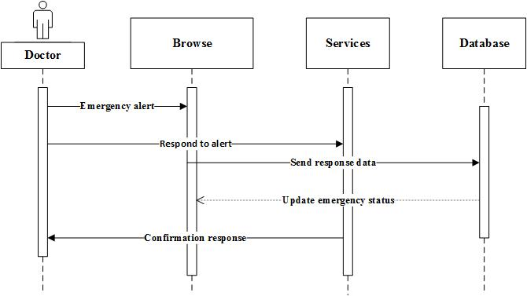
Figure 47: Sequence Diagram for Respond to Emergency Alert
- View Customer pet history

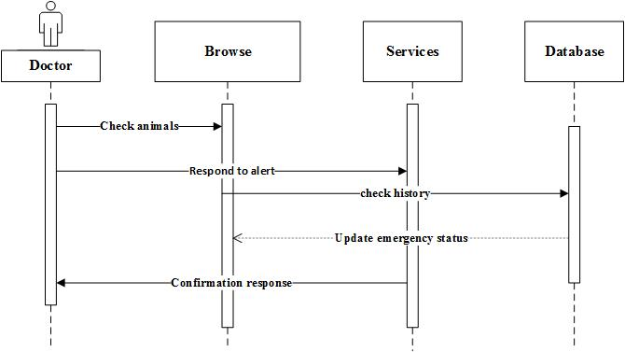
Figure 47: Sequence Diagram for View Customer pet history

State Transition Diagram
A State Transition Diagram shows how a system or object changes from one state to another based on specific events or actions. It represents the system’s behavior using states, transitions, and events. It helps visualize how different user actions or system events cause changes in the system’s workflow.

State Transition Diagram for Admin Panel

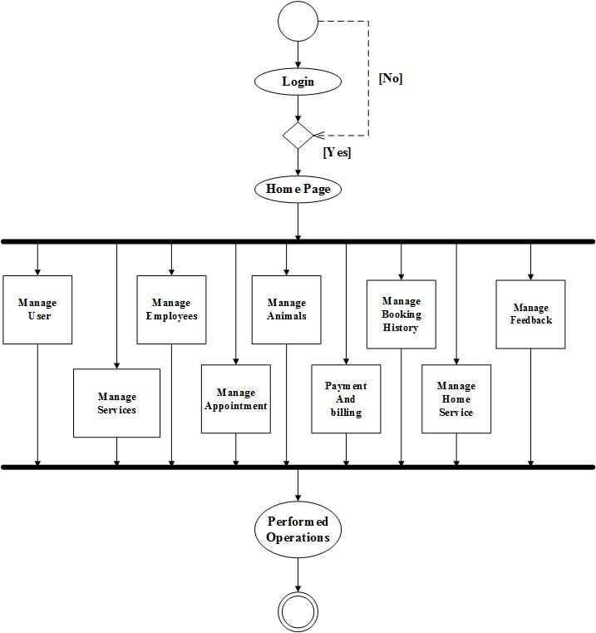

Figure 53: State diagram for Admin

State Transition Diagram for Customer

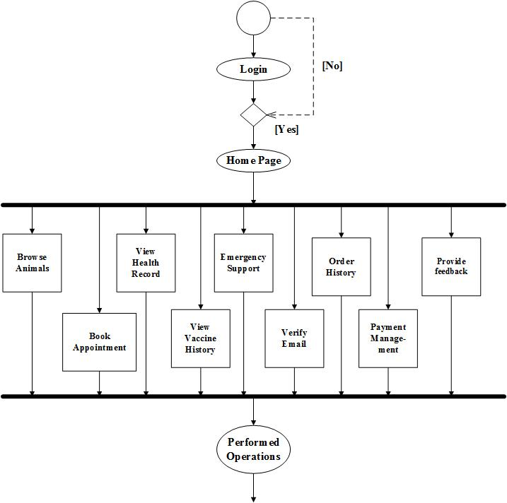

Figure 53: State diagram for Customer

State Transition Diagram for Doctor

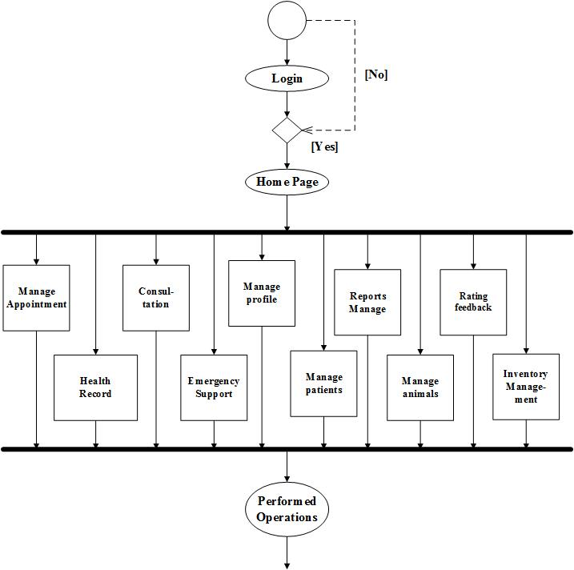

Figure 53: State diagram for Doctor

Collaboration Diagram:
A collaboration diagram, also called a communication diagram or interaction diagram, is an illustration of the relationships and interactions among software objects in the Unified Modelling Language (UML).

Collaboration Diagram for Admin Panel:

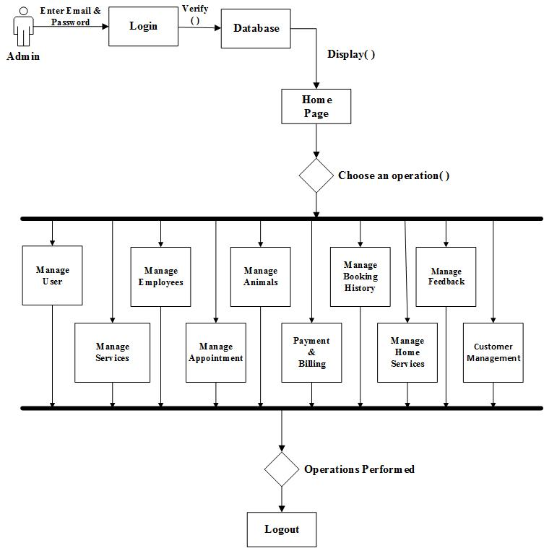

Figure 56: Collaboration Diagram for Admin Panel

Collaboration Diagram for Customer Panel:

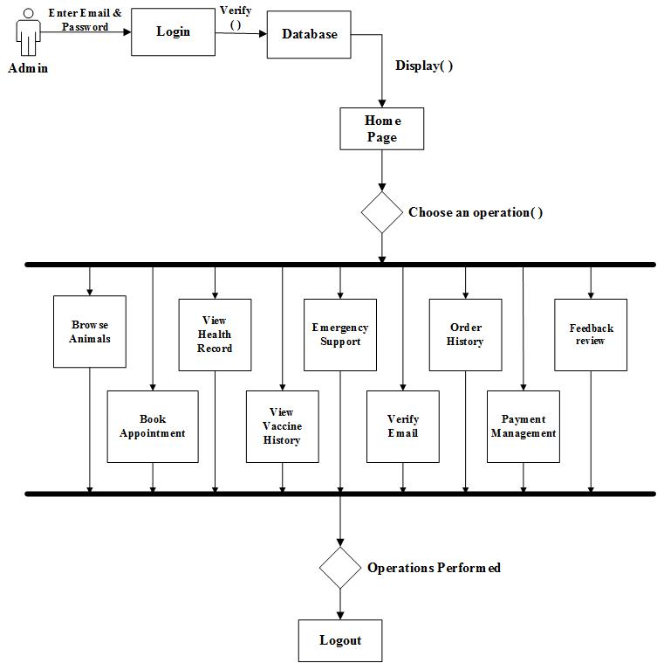

Figure 56: Collaboration Diagram for Customer Panel

Collaboration Diagram for Doctor Panel:

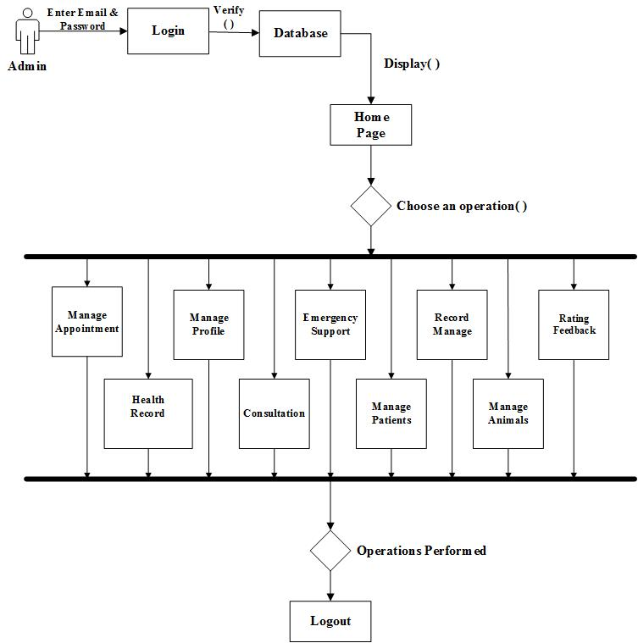

Figure 56: Collaboration Diagram for Doctor Panel

Activity Diagram
The activity diagram is a flowchart to represent the flow of control among the activity in a system.

Activity Diagram for Admin
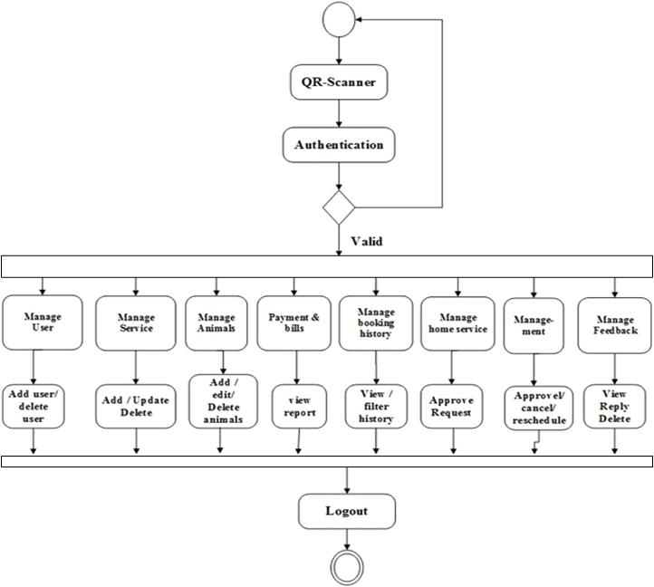

Figure 56: Activity Diagram for Admin Panel

Activity Diagram for Customer

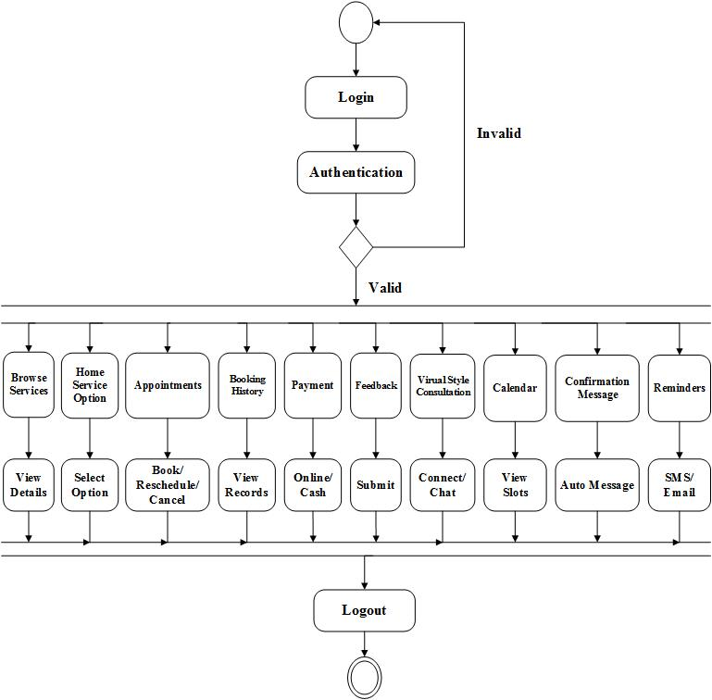

Figure 56: Activity Diagram for Customer Panel

Activity Diagram for Doctor

Object Diagram
An object diagram shows a moment-in-time view of a system. It displays actual objects (instances) and the links between them. It helps you understand how different parts of the system interact at runtime.

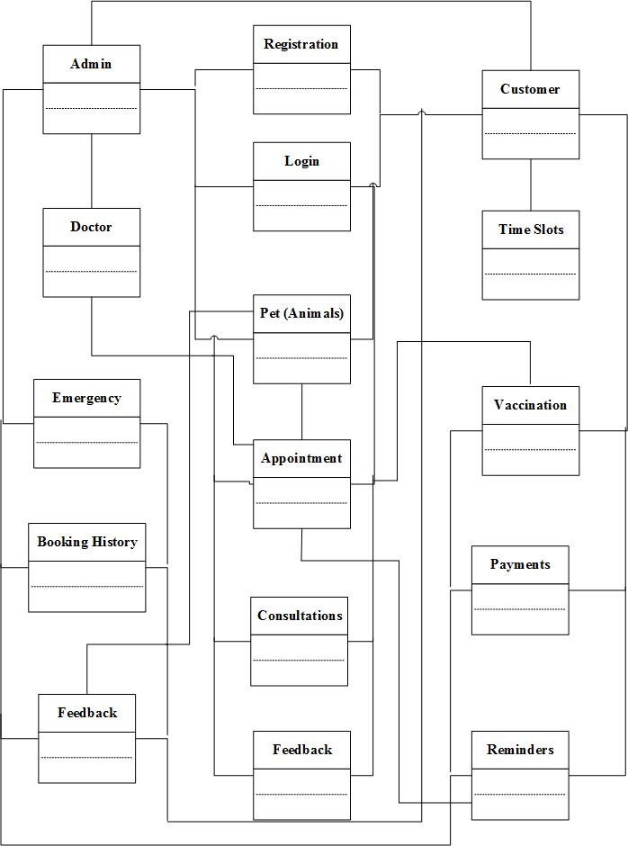

Class Diagram
A class diagram is a type of UML diagram that shows the structure of a system by depicting its classes, their attributes, methods (functions), and the relationships between them. It helps in understanding how different parts of a system interact and are organized.

Data Flow Diagram
A Data Flow Diagram (DFD) is a visual representation that shows how data moves through a system. It depicts the processes that transform data, the stores where data is kept, and the flow of information between processes, data stores, and external entities such as users or other systems. Essentially, it illustrates how data enters a system, how it is processed, and where it goes, providing a clear picture of the system’s information flow.

Data Flow Diagram Level 0
A Level 0 Data Flow Diagram is a high-level overview of a system that shows the system as a single process along with its interactions with external entities. It represents the main inputs to the system, the major outputs from the system, and the external sources or destinations of data, but it does not show the detailed internal processes. Essentially, Level 0 gives a “big picture” view of the system without going into the specifics of how the processes work internally.

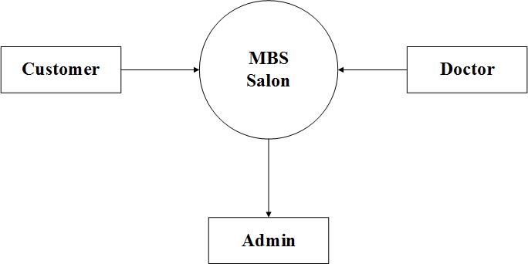

Figure 62: Data Flow Diagram Level 0

Data Flow Diagram Level 1
A Level 1 Data Flow Diagram breaks down the single process of Level 0 into multiple detailed subprocesses. It shows how data moves between these subprocesses, data stores, and external entities, providing a more detailed view of the system’s internal workings.

Data Flow Diagram Level 2
A Level 2 Data Flow Diagram provides an even more detailed view by breaking down the Level 1 subprocesses into smaller, specific processes.

Project Design

4.1 Methodology
A methodology consists of structured methods, procedures, and rules used within a specific discipline. Its primary objective is to provide a systematic and organized approach to software development. A Project Management Methodology is a collection of tools, techniques, and best practices used to plan, execute, monitor, and manage a project effectively. It assists project managers in coordinating team activities, managing resources, and ensuring timely and successful project completion.
For the Pet Sphere project, the development team follows a well-defined set of processes to initiate, plan, analyze, design, develop, test, and deploy the system. Various project management methodologies such as Waterfall, Agile, and Scrum were studied. However, Agile methodology was selected for this project due to its iterative nature, flexibility, and ability to adapt to changing requirements, which is essential for a dynamic web-based system like Pet Sphere.
4.1.1 Agile Methodology
Agile is a project management approach that is best suited for projects where requirements are not fully defined at the beginning. Its core principles include continuous delivery, iterative development, adaptability, collaboration, and short development cycles.

In Agile methodology, the Pet Sphere project is divided into smaller and manageable development cycles known as sprints, typically ranging from 1 to 4 weeks. Each sprint focuses on delivering a functional and testable part of the system. A cross-functional team of developers, designers, and stakeholders works collaboratively to deliver a potentially shippable product increment at the end of each sprint. Regular meetings are conducted to review progress, identify issues, and adjust the project scope based on feedback.
Agile Values for Pet Sphere
• Customer satisfaction
• Collaboration among team members
• Continuous improvement
• Frequent communication and feedback
• Flexible response to changing user requirements
Agile emphasizes continuous planning, execution, evaluation, and improvement instead of rigidly following a single development plan.
Sprint 1: Project Planning
During this stage, the feasibility of developing the Pet Sphere system is evaluated. This includes identifying user needs such as pet browsing and purchasing, veterinary appointment booking, online consultations, pet health record management, vaccination tracking, emergency support services, and online medicine purchasing. Administrative requirements such as user management, doctor verification, appointment management, order tracking, and report generation are also identified.
Roles and responsibilities are assigned to each team member, and timelines are defined for the development of key features, including:
• User registration and login
• Pet marketplace browsing and filtering
• Veterinary doctor profiles and availability
• Appointment booking and management
• Online payment integration
Continuous interaction with stakeholders ensures that system objectives and expectations are clearly defined.
Sprint 2: Requirement Gathering
Requirement gathering is one of the most critical phases of the Agile methodology, as improper requirement collection can lead to major issues during development.
In this phase:
• Detailed discussions are conducted with potential users, veterinary professionals, and system administrators.
• Customer Panel requirements are gathered, including registration/login, pet browsing, pet purchasing, appointment booking, online consultations, pet profile management, vaccination records, emergency alerts, payment processing, notifications, and feedback.
• Veterinary Doctor Panel requirements are collected, including profile management, availability status, appointment handling, online consultation management, and prescription handling.
• Admin Panel requirements are gathered, including user management, pet listings management, doctor verification, appointment scheduling, order tracking, system analytics, and report generation.
All requirements are documented, reviewed, and approved before the development phase begins.
Sprint 3: Analysis
The analysis phase focuses on defining and organizing the system requirements to ensure clarity and feasibility.
The following steps are performed:
• Review and validate each requirement for completeness and accuracy.
• Prioritize system features based on importance and complexity.
• Estimate development time and resources required for each module.
• Design overall system architecture and data flow.
• Identify potential risks and technical challenges.
This phase ensures that Pet Sphere meets the functional and non-functional requirements of customers, veterinary doctors, and administrators.
Sprint 4: Development
The development phase involves simultaneous frontend and backend development to build a fully functional web application.
Frontend and Backend Integration
User interfaces and server-side logic are developed concurrently to ensure smooth interaction between system components.
Frontend Development
The frontend is developed using React.js and CSS, focusing on creating a clean, responsive, and user-friendly interface for:
• Customer Panel
• Veterinary Doctor Panel
• Admin Panel
Interfaces include dashboards, pet listings, appointment scheduling, online consultation screens, payment forms, health record views, emergency alert buttons, and notification panels.
Backend Development
The backend is implemented using Node.js and Express.js. It includes:
• Database schema design using MongoDB for users, pets, doctors, appointments, health records, orders, and payments.
• RESTful APIs for authentication, bookings, consultations, payments, notifications, and admin operations.
• Integration of online payment gateways such as Jazz Cash and Easy Paisa.
Testing During Development
Unit testing and integration testing are conducted continuously to identify and resolve issues early, ensuring system stability and reliability.
Sprint 5: Testing
Testing is performed to verify that all features of the Pet Sphere system function correctly and meet user expectations.
Types of Testing
• Unit Testing
• Integration Testing
• System Testing
• User Acceptance Testing (UAT)
The following functionalities are thoroughly tested:
• Pet browsing and purchasing process
• Veterinary appointment booking and availability management
• Online consultation and payment processing
• Pet health record storage and vaccination reminders
• Emergency support and notification system
• Admin management features

Identified bugs are fixed, and necessary improvements are made before deployment.
Sprint 6: Deployment
In this phase:
• The Pet Sphere system is deployed to a live production environment using Vercel.
• System performance is optimized.
• Security checks are finalized.
• Remaining issues are resolved.
• End users, veterinary doctors, and administrators begin using the system.
Deployment ensures that Pet Sphere is fully operational and ready for real-world usage.
4.1.2 Reasons for Using Agile Methodology
1- Reduced Risk:
Continuous testing in each sprint minimizes the risk of system failure.
2- Customer Satisfaction:
Early and frequent delivery of features ensures higher user satisfaction.
3- Adaptability to Change:
Agile allows requirement changes even in later stages of development.
4.-Fast Delivery:
Functional modules are delivered incrementally within short time frames.
5-Team Support:
Agile provides a structured environment that enhances teamwork and productivity.
6-Effective Communication:
Regular meetings and reviews ensure clear and transparent communication.
7-Ensures Functional Software:
Continuous testing guarantees a working system at every stage.
8-Sustainable Development:
Developers and stakeholders maintain a steady and manageable development pace.
9-Focus on User Value:
Features are prioritized based on real user needs.
10-Better Project Control:
Agile provides improved visibility, quality control, and feedback integration.
4.2 Architecture Overview
Website architecture refers to the structured hierarchy of web pages and system components within the Pet Sphere web application. A well-designed architecture enables users to easily navigate the platform while allowing efficient communication between system components. It also helps search engines understand the relationships between different pages and services.
The web application architecture defines how system components such as the frontend interface, backend services, and database layer interact with each other. It ensures reliable data exchange, system scalability, security, and performance.
The Pet Sphere system follows a 3-Tier Architecture, which consists of the following layers:
1. Presentation Layer / Client Layer
2. Application Layer / Business Logic Layer
3. Data Layer / Database Layer
4.2.1 Architecture Overview Diagram

4.2.2 Architecture Overview by Layer
1. Presentation Layer: Client-Side Component (Frontend)
The presentation layer, also known as the client-side component, represents the user interface of the Pet Sphere web application. This layer allows customers, veterinary doctors, and administrators to interact with the system through a web browser. It displays system data, captures user actions, and sends requests to the backend server while presenting processed responses to users.
The frontend of Pet Sphere is developed using React.js and CSS, ensuring a responsive, interactive, and user-friendly experience.
Customer Panel Modules
• Customer Registration/Login: Secure user authentication using email or phone number.
• Browse Pets & Services: View pets available for sale with filters such as breed, age, color, and price.
• Veterinary Services: Browse available veterinarians and their specializations.
• Book/Reschedule/Cancel Appointments: Schedule physical or online consultations.
• Home Service Option: Request veterinary services at home.
• View Appointment & Order History: Access past and upcoming bookings.
• Online Payment Options: Pay using Jazz Cash or Easy Paisa.
• Pet Profile Management: Add pets and manage health details.
• Vaccination & Health Records: View and update pet medical history.
• Emergency SOS Support: Alert nearby vets, shelters, or ambulance services.
• Notifications & Reminders: Receive appointment and vaccination alerts.
• Feedback & Ratings: Submit reviews for doctors and services.
• Online Consultation: Chat or video consultation with veterinary doctors.
Veterinary Doctor Panel Modules
• Doctor Registration & Verification: Profile setup and verification.
• Profile Management: Manage specialization, experience, and consultation fees.
• Availability Status: Set availability as Available, Busy, or Offline.
• Appointment Management: Accept, reschedule, or cancel appointments.
• Online Consultation Management: Conduct video or chat consultations.
• Prescription Management: Issue digital prescriptions.
• View Consultation History: Access patient interaction records.
• Earnings & Payment Tracking: Monitor consultation fees.
Admin Panel Modules
• User Management: Manage customers, doctors, and system users.
• Pet & Marketplace Management: Add, update, or remove pet listings.
• Doctor Verification & Status Management: Approve or reject doctor profiles.
• Appointment & Order Management: Monitor bookings and purchases.
• Medicine & Store Management: Manage prescribed medicines.
• Reports & Analytics: Generate sales, booking, and system usage reports.
• Emergency Support Management: Monitor SOS requests.
• Feedback Management: Review and manage user feedback.
• Notification Management: Send system-wide alerts and reminders.
2. Application Layer: Server-Side Component (Backend)
The application layer contains the core business logic of the Pet Sphere system. It processes requests received from the frontend, applies business rules, and returns appropriate responses.
This layer is developed using Node.js and Express.js and provides RESTful APIs to support frontend functionality.
Key responsibilities include:
• User authentication and authorization
• Appointment scheduling and availability checking
• Veterinary consultation management
• Payment processing
• Emergency alert handling
• Notification and reminder services
• Feedback and rating management
• Admin control and reporting
The backend ensures that:
• Appointments are not double-booked
• Doctors are available at selected times
• Secure and accurate payments are processed
• Data consistency and integrity are maintained
3. Data Layer: Database Component
The data layer is responsible for permanent and secure data storage. MongoDB is used as the database for Pet Sphere due to its scalability and flexibility.
The database stores:
• Customer profiles
• Veterinary doctor profiles
• Pet listings and pet profiles
• Appointments and consultations
• Medical records and vaccination history
• Payments and transaction records
• Emergency support logs
• Feedback and ratings
• Admin reports and analytics data
The data layer ensures:
• Data integrity and consistency
• Low redundancy
• Fast data retrieval
• Secure access control
• Reliable backup and recovery
4. Backend Technology: Node.js & Express.js
Node.js is used as the backend runtime environment, providing high performance and scalability for handling multiple user requests. Express.js is used as the server framework to manage routes, APIs, and middleware efficiently.
Node.js manages:
• API request handling
• Business logic execution
• Authentication and authorization
• Appointment and consultation workflows
• Payment gateway integration
• Notification services
This technology stack ensures high efficiency, real-time processing, and smooth system performance.
5. Deployment & Development Environment
The Pet Sphere system is developed and tested locally using modern development tools. After testing, the application is deployed on Vercel, which provides fast and reliable hosting.
Deployment features include:
• Continuous deployment
• Secure HTTPS access
• Scalable infrastructure
• High availability
This ensures that Pet Sphere is accessible, secure, and ready for real-world usage.
4.3 Database Design
Database design is the process of organizing data and defining how it will be stored, accessed, and managed within a system. It involves a structured set of steps to create an efficient, secure, and reliable database that fulfills system requirements. For the Pet Sphere system, an effective database design ensures that user information, pet details, veterinary records, appointments, transactions, and emergency data are handled efficiently and securely.
A well-designed database plays a critical role in ensuring smooth system operations, data accuracy, and system scalability.
Some important points considered for designing the Pet Sphere database include:
• Data consistency and integrity to ensure accurate and reliable information.
• Low data redundancy to avoid duplicate storage of the same information.
• Efficient searching and retrieval through indexing and optimized queries.
• Security measures using access control and validation rules to protect sensitive data.
• Atomic data storage, where data is stored in its smallest meaningful units (e.g., separating pet details, owner details, and medical records).
Depending on the functional requirements of the Pet Sphere system, these principles may be extended or refined; however, they form the foundation of a reliable and efficient database design.
4.3.1 Data Model
The data model defines how data is logically and physically structured within the Pet Sphere system. It serves as a blueprint for organizing data elements, defining relationships among them, and ensuring that data can be efficiently stored, accessed, and managed.
The data model helps the system support core functionalities such as pet marketplace operations, veterinary appointment scheduling, health record management, payment processing, and administrative reporting.
4.3.2 The Data Model Used in Pet Sphere
The Pet Sphere system uses a document-based (NoSQL) data model implemented through MongoDB. Unlike traditional relational databases, MongoDB stores data in flexible, JSON-like documents, which makes it suitable for handling complex and evolving data structures.
In this model:
• Each document represents a record (e.g., user, pet, appointment).
• Each field represents an attribute of that record.
• Related data can be embedded or referenced, allowing efficient data retrieval.
This data model is ideal for Pet Sphere as it efficiently manages diverse and interconnected data such as:
• Customer and veterinary doctor profiles
• Pet listings and pet profiles
• Appointments and online consultations
• Medical and vaccination records
• Orders, payments, and subscriptions
• Emergency support logs and notifications
The NoSQL data model provides scalability, flexibility, and high performance, making it suitable for a modern web-based system like Pet Sphere.
4.3.3 Entity Relationship Diagram (ERD)
An Entity Relationship Diagram (ERD) is used during the system analysis phase to visually represent the main entities involved in the Pet Sphere system and the relationships among them.
• Entities represent real-world objects such as Customer, Veterinary Doctor, Pet, Appointment, Health Record, Payment, Order, and Admin.
• Attributes define the properties of each entity, such as customer name, pet breed, doctor specialization, appointment date, and payment status.
• Relationships describe how entities interact, for example:
• One customer can own multiple pets.
• One veterinary doctor can handle many appointments.
• Each appointment is linked to one customer and one pet.
• Cardinality defines the number of instances involved in a relationship (one-to-one, one-to-many, or many-to-many).
• Modality specifies whether participation in a relationship is mandatory or optional.
The ERD provides a clear conceptual view of the database structure and serves as a guide for implementing the actual database schema in MongoDB for the Pet Sphere system.

Feedback | Reminders | Notification | Emergency | Health  Record | Home Service | Payment | Appointment | Services | Doctors | Pets | Login | Registration | Customer | Admin | Module / Entity
View | Send | Send | Monitor | Monitor | Manage | Monitor | Manage | Generate Receipt | Manage | Manage | Verify | Verify | Manage |  | Admin
Give | Receive | Receive | Use | View | Request | Pay |  | Pay | Book/Cancel | View /  Buy | Login | Register |  |  | Customer
 |  |  |  |  |  |  |  |  |  |  |  |  | Register |  | Registration
 |  |  |  |  |  |  |  |  |  |  |  |  | Login |  | Login
 |  |  |  | Linked |  |  |  |  | Is For |  |  |  | View | Manage | Pets
 |  |  | Respond | Update | Provide | Receive | Attends | Is Linked |  |  |  |  | View | Verify | Doctors
 |  |  |  |  | Available |  |  |  | Has |  |  |  | Browse | Manage | Services
 | Remind | Notify |  | Update | Linked | Linked |  |  | Assigned To |  |  |  | Book | Manage | Appointment
 |  | Notify |  |  |  |  | Has |  | Has |  |  |  | Pay | Monitor | Payment
 | Remind | Notify |  |  |  | Pay |  |  |  |  |  |  | Request | Manage | Home Service
 | Remind | Notify |  |  |  |  |  |  |  | Linked |  |  | View | Monitor | Health Record
 |  | Alert |  |  |  |  |  |  | Has |  |  |  | Trigger | Monitor | Emergency
 |  |  | Alert | Notify | Notify | Notify |  |  |  |  |  |  | View | Send | Notification
 |  |  |  | Reminder | Remind |  |  |  |  |  |  |  | View | Send | Reminder
 |  |  |  |  | Has |  |  | Linked |  |  |  |  | Give | Manage | Feedback

4- Project Design

4.1. Methodology
A methodology consists of structured methods, procedures, and rules for a specific discipline. Its goal is to provide a systematic approach to software development.

